How to Check if You Have Paid Tuition Fees

[NOTICE]
Following procedure is only applied to students who have paid tuition fees with virtual account numbers given by KAIST.

- Please visit the website of Woori Bank (http://www.wooribank.com/)
- Click “개인뱅킹” (meaning personal banking) in Step 1 below. See number 1.
- Click “취소” (see number 2) if a grey pop-up window is shown like a picture in Step 2.
- Click number 3 and 4 in Step 3 each.
- If you see a page like in Step 4, you have come to the right place. The next step could be challenging since you need to find KAIST in Korean. KAIST in Korean is “한국과학기술원”. If you click the combo box, you will see a list of universities in Korea and they are listed in Korean alphabetical order. Please find “한국과학기술원”.
- The picture in Step 5 is the right one for KAIST.
- Type in your student number in the box right below. See number 5.
- Click number 6 saying “조회”.
- You will see your payment details and can check if you have paid the tuition fees for your intended semester.

[Step 1]
1
[Step 2]
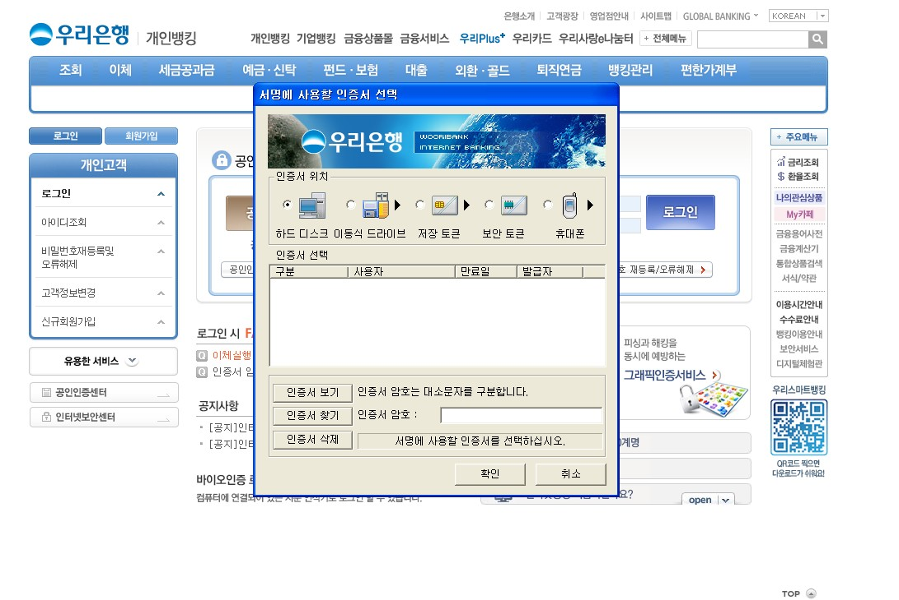
2
[Step 3]
3
4
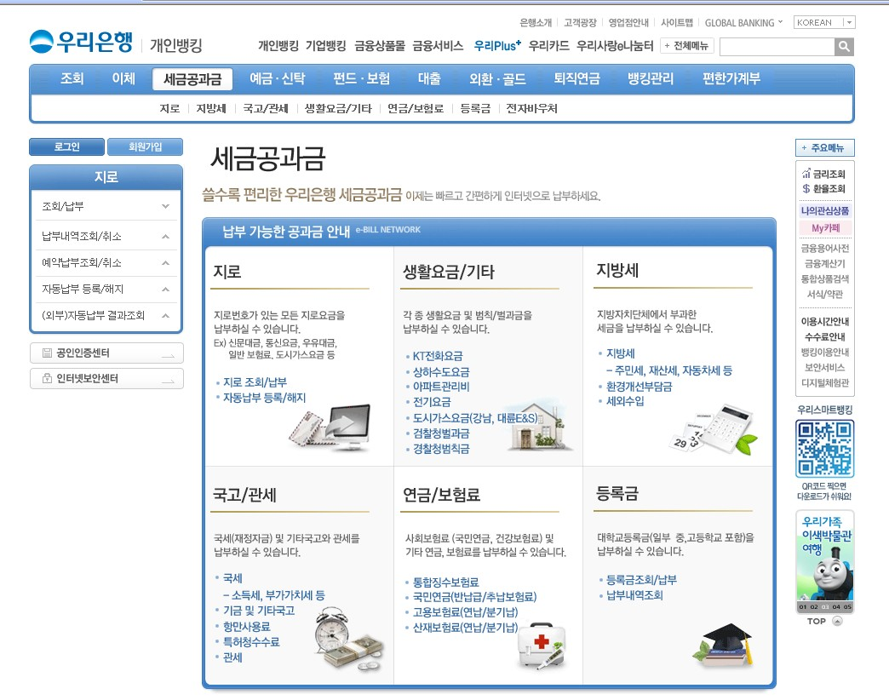

[Step 4]
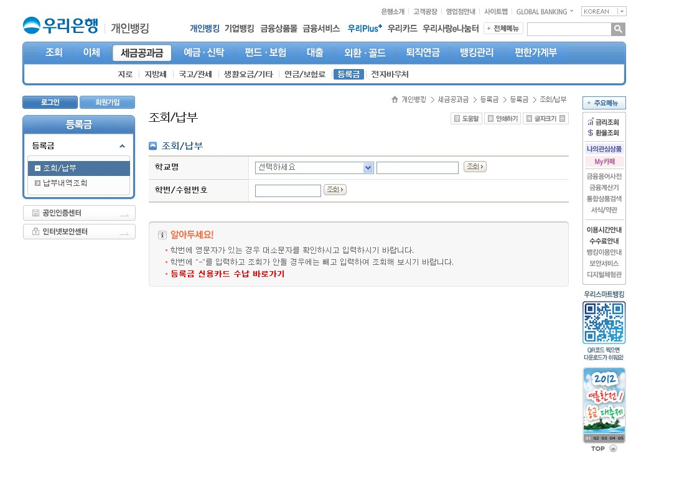
Click the combo box and find KAIST in Korean

[Step 5]
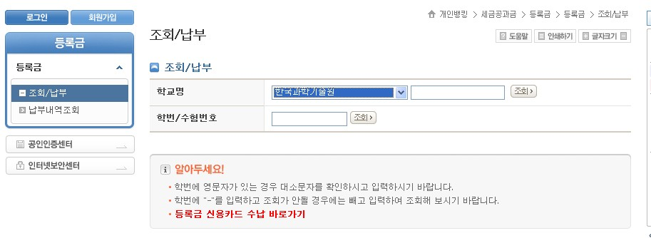
6: Click this and see the details of your payment
This is KAIST
5: Type in your student number here

